**Laser tag arena:**

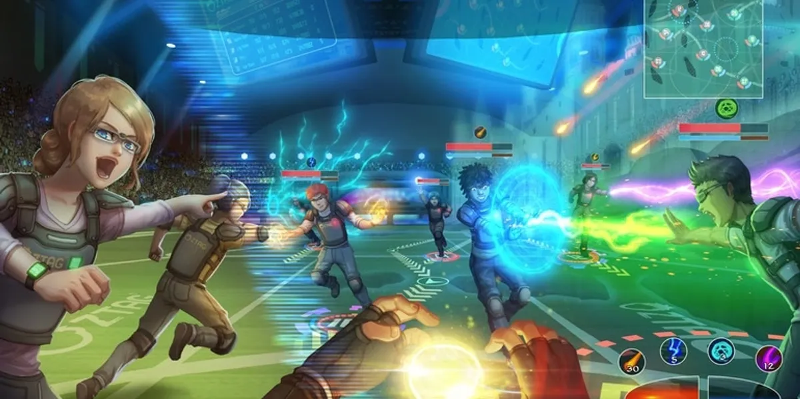

Description:

33 m x 15 m arena () that is divided into two floors:

* First floor includes:
  + Lobby check-in area.
  + A briefing room.
  + Back office.
* Second floor:
  + Play arena.
  + spectators.

**First floor design:**

References:

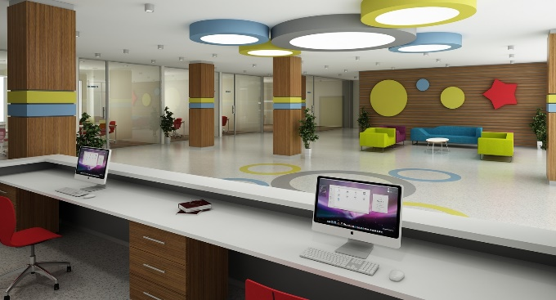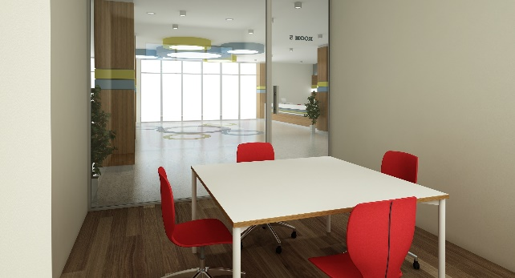

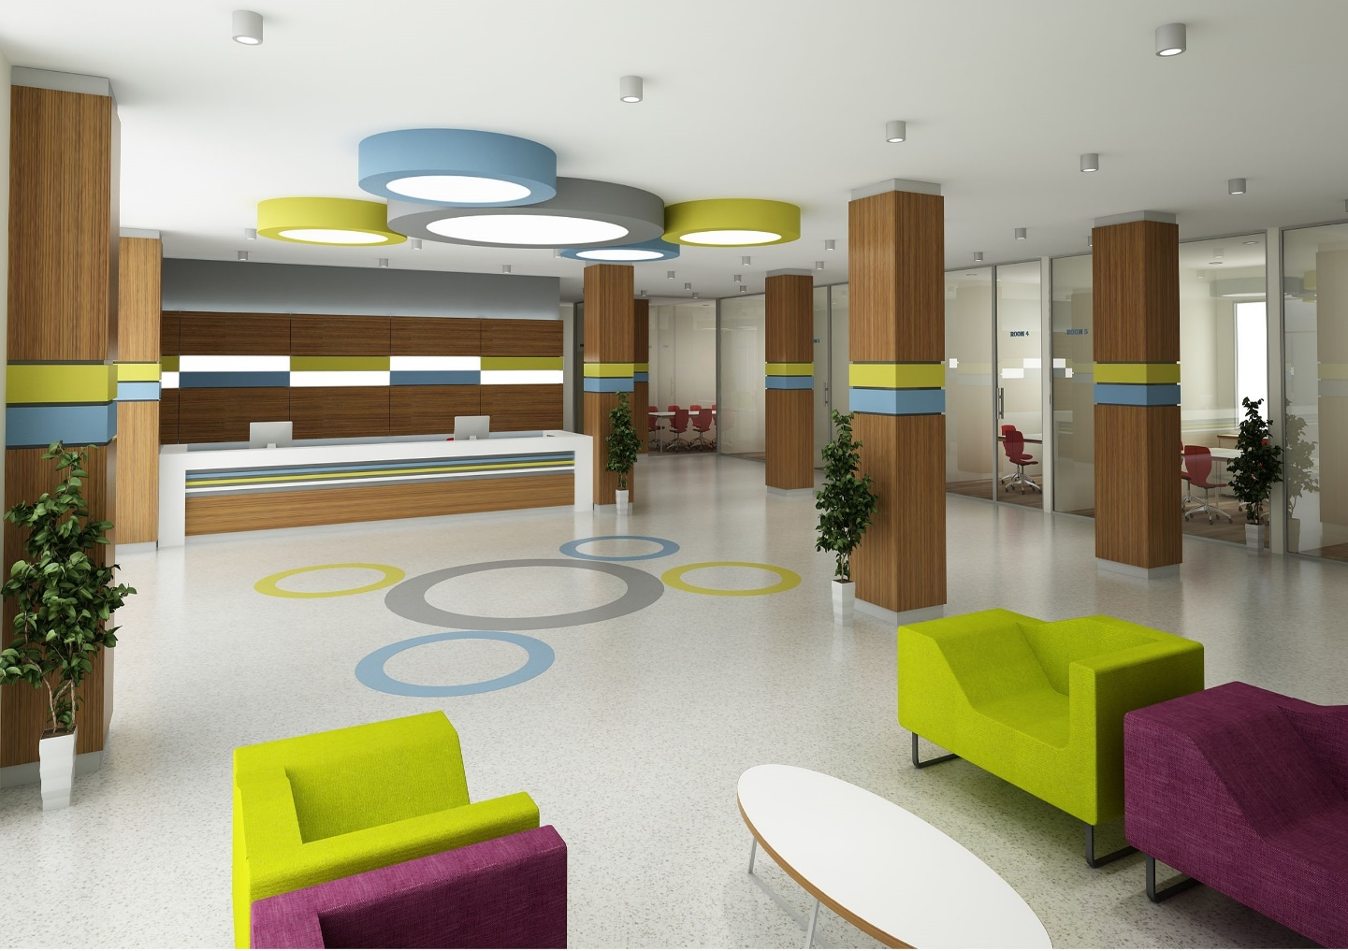

Models needed:

* Reception chairs and table.
* Receptionist’s chair.
* Receptionist’s large office table.
* office drawers.
* Office flowers.
* Computer/Laptop.
* A couple of Notes.
* Large office table.
* Two Doors.

**Arena area:**

References:

